# WAR! Program

This program will allow the user to play the classic card game War.

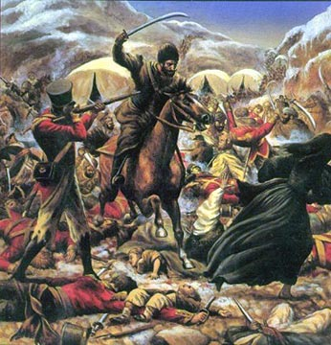

The object of the game is to capture all of the other player’s cards. Each player starts with half the deck and the top card of each player’s pile is revealed each turn. The player with the higher card wins the two competing cards, and puts those cards on the bottom of their pile. In the event of a tie, three cards are removed from each pile, face down. A fourth card is flipped to determine the winner of all ten cards. Play continues until a player loses all cards, or does not have enough to settle a tie. Use queues to implement the two players’ piles.

# Required Function: CheckWin

This function takes the two queues as arguments, and returns values indicating if there is a winner, and who it is.

# Required Function: DealCards

This function deals the decks

# Required Function: PlayTurn

This function takes two stacks as an argument. It must run through a turn of war, including enqueueing the winner’s cards.

# Notes

The program needs to display an error message appropriate to each type of error.

The program must keep track of the number of turns used to complete the war and display it

when completed.

The program should loop to allow replaying.

The program must be well-commented.

The program must be printed out and turned in with this paper attached. (THIS SIDE UP)

WAR! Program Name ___________________

|  |  |  |
| --- | --- | --- |
| Criteria | Points Possible | Points Earned |
| Game correctly checks for a win | 25 |  |
| Game correctly resolves ties | 25 |  |
| Game resets when looped | 15 |  |
| Game counts the number of turns and displays it after a win | 15 |  |
| Game is displayed clearly | 15 |  |
| Commented | 5 |  |
| Late | -5 points per day late |  |
| Total: | 100 |  |